**QUESTION 1:**

Redraw the topology and attach the router CLI configuration and packet transfer output.

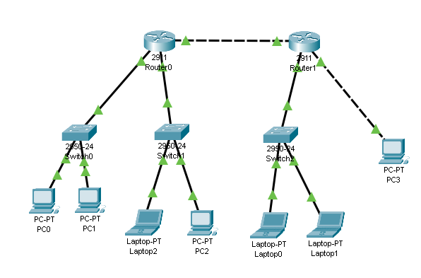

**QUESTION 2:**

Redraw the topology and apply eigrp and ospf routing protocols. Provide the routers CLI and packet transfer screen shots as an output.

